**Homework 9 Solution**

1. Is there a primitive root modulo 15? Once you figure this out, check out “Carmichael function” on Wikipedia (this was mentioned earlier as well). Briefly describe what the function is with two-three different examples to clarify the concept.

* Since $15=3*5$, Worksheet 19 Theorem 3 tells us that there does not exist a primitive root modulo 15. But if we instead attempt to find one. First, note $ϕ(15)=8$.
* $gcd(2, 15)=1$ but $2^{4}≡1 (mod 15)$ so 2 is not a primitive root modulo 15
* $gcd(4, 15)=1$ but $4^{2}≡1 (mod 15)$ so 4 is not a primitive root modulo 15
* $gcd(7, 15)=1$ but $7^{4}≡1 (mod 15)$ so 7 is not a primitive root modulo 15
* Since 8, 11, 13, and 14 are negative of 2, 4, 7, 1, they are also not primitive roots modulo 15.
* Those were all the integers relatively prime to 15 so there is not a primitive root modulo 15.
* The Carmichael function is similar to the Euler Phi function in both its calculation and its meaning. The Carmichael function, denoted $λ(n)$, determines the smallest exponent $e$ for which $a^{e}≡1 (mod n)$ for any $a$ which is relatively prime to $n$. Through Fermat's Little Theorem we know that $ϕ(n)$ is an upper bound for $λ(n)$ but we have found examples where they differ.
* For $n=15$ we know $ϕ(15)=8$ but from the above work $a^{4}≡1 (mod 15)$ for all $a$ relatively prime to 15 and 4 is the smallest such power because $2, 2^{2}, 2^{3}≠1(mod 15)$. So $λ(15)=4.$
* But, these functions will be equal whenever there exists a primitive root of $n$. This is because we know $ϕ(n)≥λ(n)$ and if there exists a primitive root of $n$ then there exists at least one element whose order is $ϕ(n)$ so $λ(n)≥ϕ(n)$. Thus if there exists a primitive root modulo $n$ then $λ(n)=ϕ(n)$.

1. Find a primitive root *g* modulo 50 and express all other primitive roots in terms of *g.*

phi(50) = 20. So we need to check the powers of 20/2=10 and 20/5=4 and make sure both are not zero. We start with the first number relatively prime to 50, 3.

We see that 3^(10) = 49 mod 50 and 3^(4)= 31 mod 50. Since neither of these is 1, 3 is a primitive root mod 50.

To express the other primitive roots mod 20, we use 3^(k) for all k relatively prime to 20. This gives us the list of 3 to the power of 1, 3, 7, 9, 11, 13, 17, 19

1. Show that at least one of 2, 3, or 6 is a quadratic residue modulo *p* for $p>5.$

Assume that 2 and 3 are quadratic non residues, because if they were residues, we’d be done. This means that 2 ^ (p-1) / 2 == -1 mod p and 3 ^ (p-1) / 2 == -1 mod p

Next we see

6 ^ (p-1) / 2 = (2*3) ^ (p-1)/2 = { 2 ^ (p-1) } * { 3 ^ (p-1) / 2 } =

Examining mod p we get (-1) (-1) mod p which is 1 mod p so 6 must be a quadratic residue if 2 and 3 are not.

1. Determine if each of 29 and 41 has square-roots modulo 239.

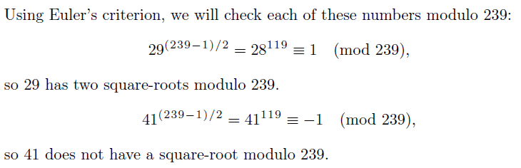

1. Determine the number of primitive roots modulo 491.



1. Suppose *p* is an odd prime. Let *g* be an odd number that is a primitive root modulo $p^{m}.$ Show that *g* is also a primitive root modulo $2p^{m}.$

* Note that $ϕ(2p^{m})=ϕ(2)ϕ(p^{m})=ϕ(p^{m})$.
* We will prove the statement by contradiction. Assume $g$ is an odd primitive root modulo $p^{m}$ and not a primitive root modulo $2p^{m}$.
* Since $g$ is a primitive root modulo $p^{m}$ we know $gcd(g, p^{m})=1$. Since $g$ is odd we know $gcd(g, 2)=1$. Thus $gcd(g, 2p^{m})=1$ so the order of $g$ modulo $2p^{m}$ is defined.
* If $g$ is not a primitive root modulo $2p^{m}$ then there exists an $e<ϕ(2p^{m})=ϕ(p^{m})$ such that $g^{e}≡1 (mod 2p^{m})$. But $g^{e}≠1 (mod p^{m})$ because $e<ϕ(p^{m})$ and the order of $g$ modulo $p^{m}$ is $ϕ(p^{m})$.
* This is a contradiction because if $a≡1 (mod 2p^{m})$ then $a≡1 (mod p^{m})$ for any $a$.
* Thus we have proven that if $g$ is an odd primitive root modulo $p^{m}$ then $g$ is a primitive root modulo $2p^{m}$.